JVM Memory Model

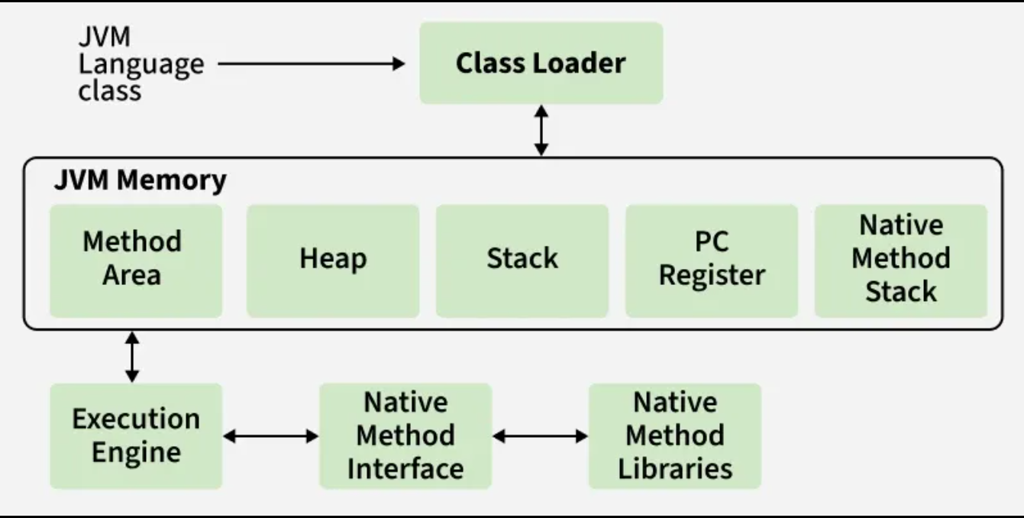

JVM Memory Model (Runtime Memory Areas)
The JVM divides memory into shared areas (used by all threads) and thread-specific areas.

1. Heap
- Stores objects and arrays
- Shared across all threads
- Managed by the Garbage Collector
- Divided into:
  - Young Generation (Eden, Survivor spaces)
  - Old Generation (long-lived objects)
📌 Most memory leaks happen here.

2. Method Area (aka Metaspace in modern JVMs)
- Stores class-level data
  - Class metadata
  - Method bytecode
  - Static variables
  - Runtime constant pool
- Shared across threads
- Since Java 8, implemented as Metaspace (uses native memory, not heap)

3. Java Stack
- One stack per thread
- Stores stack frames for method calls
- Each frame contains:
  - Local variables
  - Operand stack
  - Method return info
📌 StackOverflowError occurs when this fills up (deep recursion).

4. PC (Program Counter) Register
- One per thread
- Keeps track of the current instruction being executed
- Very small but critical for thread switching

5. Native Method Stack
- Used for native (non-Java) code written in C/C++
- Works alongside the Java Stack

Quick Summary Table
Memory Area | Thread Safe? | Stores
Heap | ❌ Shared | Objects, arrays, Instance variables
Method Area / Metaspace | ❌ Shared | Class metadata, static variables,  Method bytecode, Constant pool, Interfaces
Java Stack | ✅ Thread-local | Local variables, method calls
PC Register | ✅ Thread-local | Current instruction
Native Stack | ✅ Thread-local | Native method data

Key Takeaways (Interview Gold ✨)
- Heap + Method Area → shared
- Stack + PC + Native Stack → thread-specific
- Garbage Collection works only on the Heap
- Metaspace grows dynamically (unlike old PermGen)

Real Java Example
class Person {
static String species = "Human"; // static variable : Method Area/Mataspace

String name; // instance variable : Heap

Person(String name) {
this.name = name;
}

void sayHello() {
int age = 25; // local variable : Stack
System.out.println("Hi, I'm " + name + ", age " + age);
}
}

public class Main {
public static void main(String[] args) {
Person p1 = new Person("Alice"); // p1: stack, Person: Heap, “Alice”: Heap(pool)
p1.sayHello();
}
}

Garbage Collection (GC) in the JVM

GC automatically finds objects you’re no longer using and frees their memory, so you don’t have to manually free() anything like in C/C++.

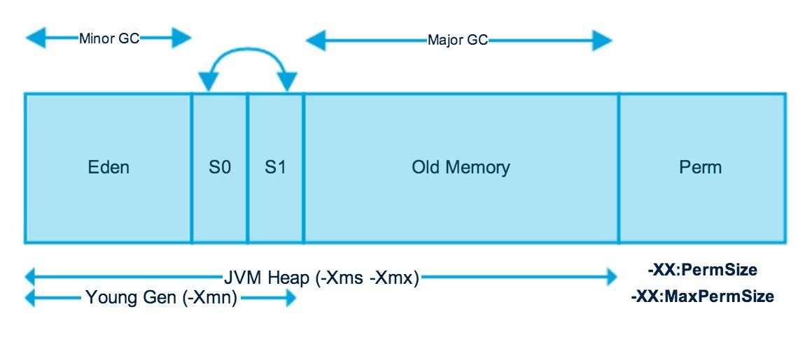

The Heap (where objects live) is split into generations:
1️⃣ Young Generation (most action happens here)
- Eden – new objects are created here
- Survivor spaces (S0, S1) – objects that survive GC get moved here
👉 Most objects die young (temporary objects, loop variables, etc.)

2️⃣ Old (Tenured) Generation
- Objects that survive multiple GCs in Young Gen
- Long-lived objects (caches, singletons, session data)
GC here is slower but less frequent

3️⃣ Metaspace (not heap)
- Class metadata (methods, constant pool, etc.)
- Native memory (since Java 8)

How GC actually decides what’s garbage
🔗 Reachability
GC starts from GC Roots, such as:
- Local variables on the stack
- Active threads
- Static fields
- JNI references
If an object can’t be reached from any GC Root → ❌ garbage.

Types of GC events
🟢 Minor GC
- Cleans Young Generation
- Fast and frequent
- Copies surviving objects:
  - Eden → Survivor
  - Survivor → Survivor / Old Gen

🔴 Major GC
- Cleans Old Generation
- Slower
- Often includes compaction

🚨 Full GC
- Cleans entire heap (Young + Old + Metaspace)
- Stop-The-World (all app threads pause)
- Bad for latency-heavy apps 😬

Common GC algorithms (simplified)
⚡ Serial GC
- Single-threaded
- Simple, small apps
⚙️ Parallel GC
- Multi-threaded
- Throughput-focused (batch jobs)
⏱️ G1 GC (default in modern JVMs)
- Splits heap into regions
- Predictable pause times
- Great general-purpose choice
🚀 ZGC / Shenandoah
- Ultra-low pause times (milliseconds)
- For large heaps & latency-sensitive systems

Why “Stop-The-World” happens
During certain GC phases:
- Object graph must be stable
- Threads are paused briefly
- Modern collectors minimize this time, but can’t eliminate it entirely

Key things developers should remember
✅ GC is automatic, but not magic
✅ Creating too many short-lived objects increases GC pressure
✅ Memory leaks still exist (objects referenced forever)
✅ Tuning GC ≠ first step (fix code first)

Mental model (easy to remember)
- Young Gen = busy airport → lots of short trips
- Old Gen = people who moved in permanently
- GC = eviction notice for unreachable objects

GC Pause:
Garbage Collection in the JVM is performed by dedicated GC threads. During certain GC phases, the JVM temporarily stops all application threads (Stop-The-World) to safely identify and reclaim unreachable objects. This temporary halt of application threads is called a GC pause.

Which GC should you use? (Quick guide)
Use case | Recommended GC
General server apps | G1 GC
Low latency (<10ms pauses) | ZGC
High throughput batch jobs | Parallel GC
Small memory / embedded | Serial GC
Ultra-low pause + large heap | ZGC / Shenandoah

Garbage Collectors by JDK Version
GC Name | JDK Introduced | Default In | Status / Notes
Serial GC | JDK 1.2 | Never default (except tiny heaps) | Simple, single-threaded; good for small apps
Parallel GC (Throughput GC) | JDK 1.2 | JDK 8 | Focus on throughput; multi-threaded
CMS (Concurrent Mark Sweep) | JDK 1.4 | JDK 5–8 | Low-latency GC; deprecated in JDK 9, removed in JDK 14
G1 GC (Garbage First) | JDK 7 | JDK 9+ | Balanced GC; low pause times; current mainstream default
ZGC | JDK 11 (experimental) | Never default | Ultra-low latency (sub-10ms); production-ready since JDK 15
Shenandoah GC | JDK 12 (Red Hat) | Never default | Low-latency; concurrent compaction
Epsilon GC | JDK 11 | Never default | No-op GC (doesn’t reclaim memory); testing only

🔁 What “Throughput” Means (in GC context)
Throughput = how much useful application work your JVM gets done over time.
More precisely:
GC throughput = % of total time the JVM spends running your application
(not doing garbage collection)
Simple formula
Throughput = (Total time − GC time) / Total time
Example
- App runs for 100 seconds
- GC pauses total 5 seconds
➡️ Throughput = 95%

🧠 Why Throughput Matters
Higher throughput means:
- More requests processed
- More transactions completed
- Better CPU utilization
- Higher batch job completion speed
This is especially important for:
- Batch jobs
- ETL
- Data processing
- Analytics
- Offline workloads

⚖️ Throughput vs Latency (the Trade-off)
Concept | Meaning
Throughput | How much work gets done
Latency | How long a single request waits

GC impact
- High-throughput GC → fewer GC cycles, longer pauses
- Low-latency GC → many tiny pauses, more GC work overall

Window command to check which GC is running:
java -XX:+PrintCommandLineFlags -version

